**JEWELLERY_SHOP_MANAGEMENT_SYSTEM (JSMS)**

4th Semester Project on DBMS for Jewelry Shop Management

The Online Jewelry Shop is essentially designed to create an application program that helps people find and purchase the latest designs of jewelry across various categories like gold, silver, and diamonds. It is beneficial because it simplifies the process of buying products online. Today, most jewelry shops are useful for shopping sites. The admin handles a lot of paperwork and uses desktop tools like MS Excel to manage user data in digital format. In this proposed jewelry system, it will operate on a server, allowing users to manage all registration activities.

**Software requirements**

* **System:** Windows
* **Code Editor:** Notepad
* **Backend & Database**: Xampp-apache server

**Phase 1:**

DML:



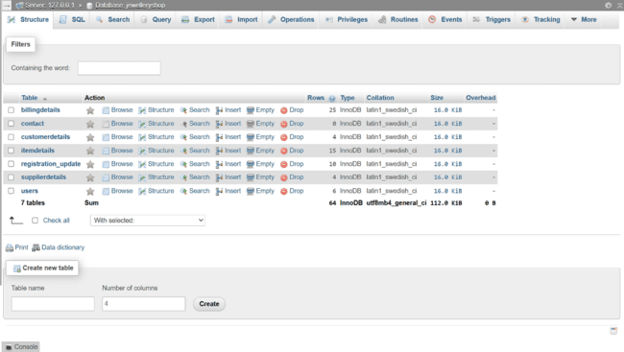

DML:

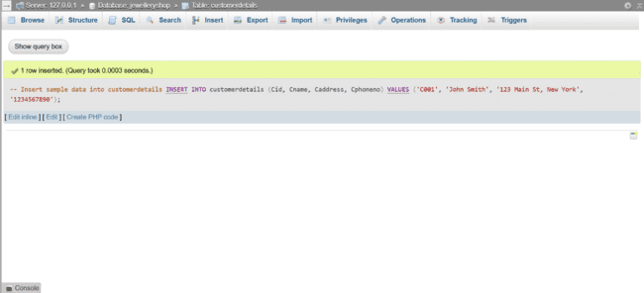

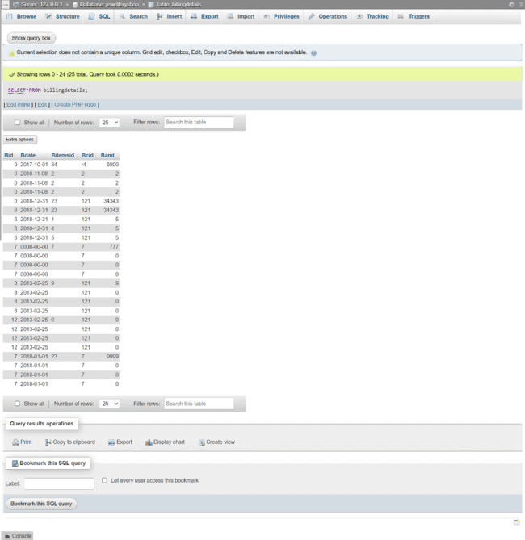

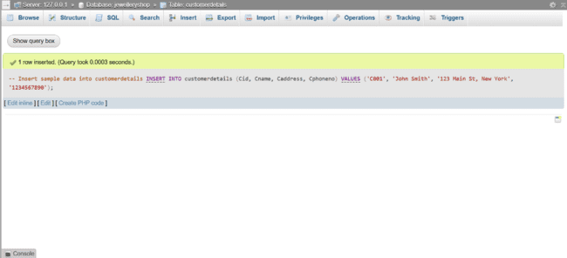

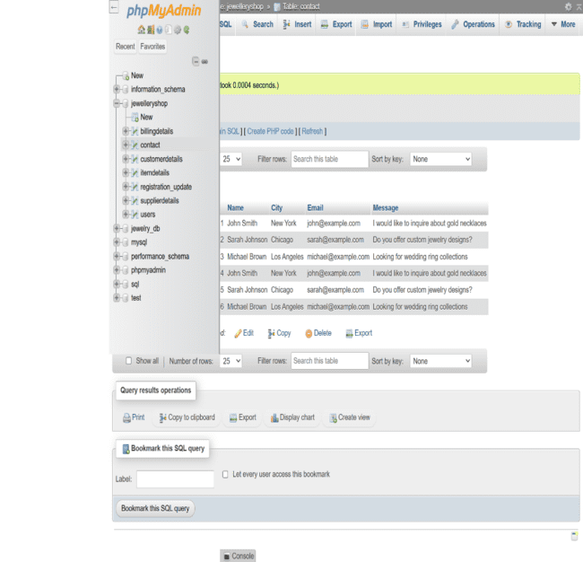

SQL CLAUSES:

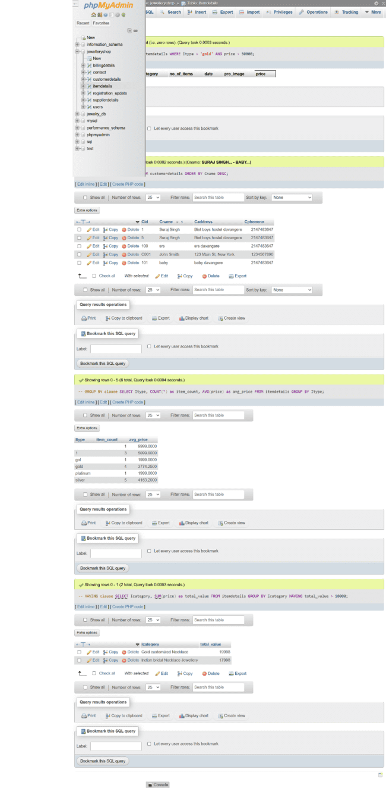

Logical Operators

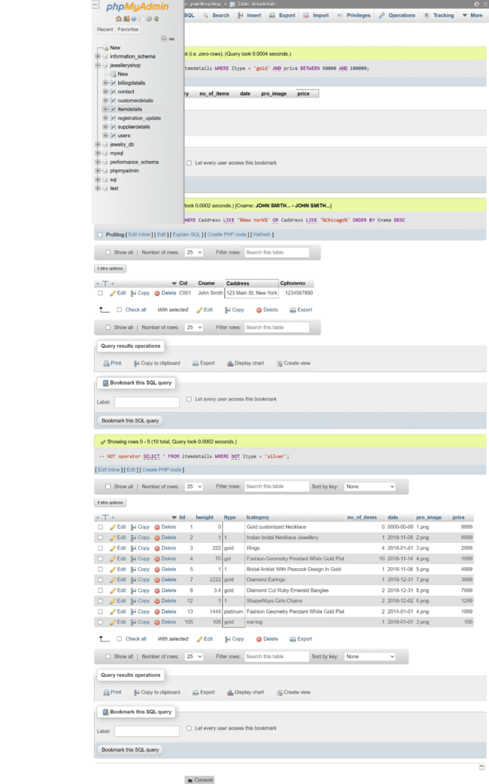

Select Functions

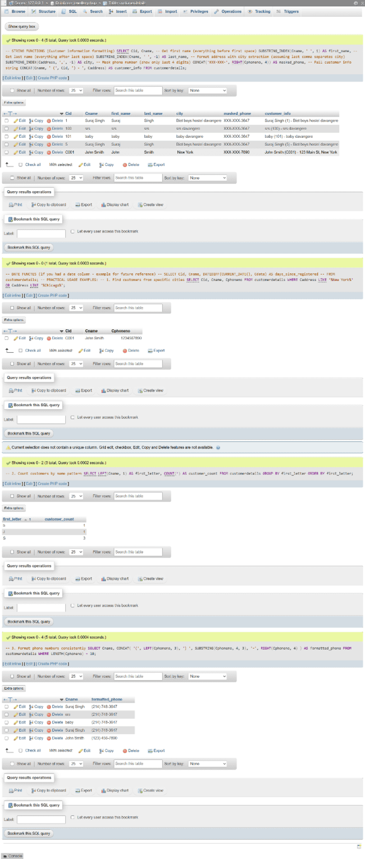

Aggregation Functions

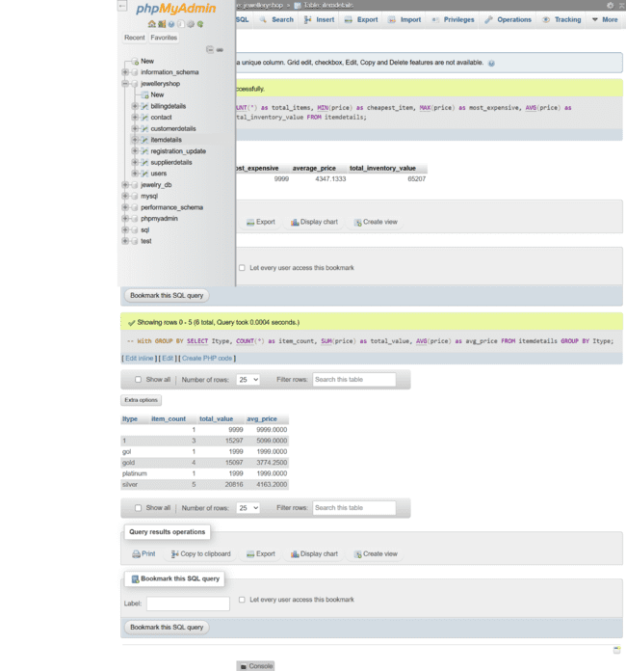

String Functions

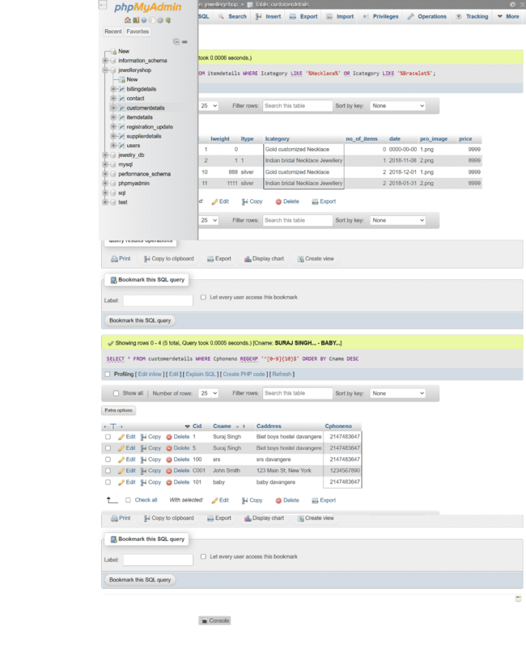

Joins:

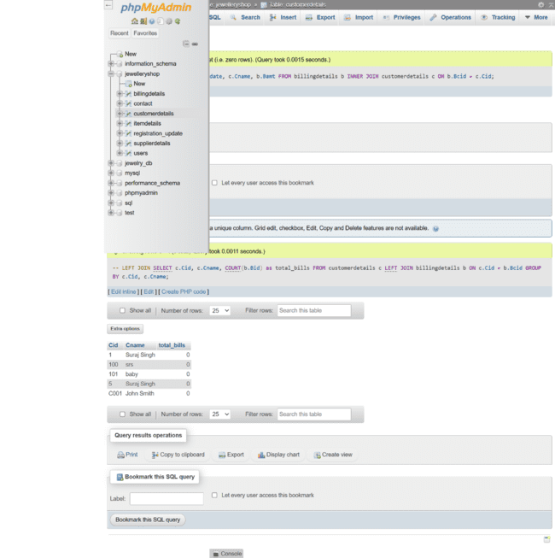

Views:

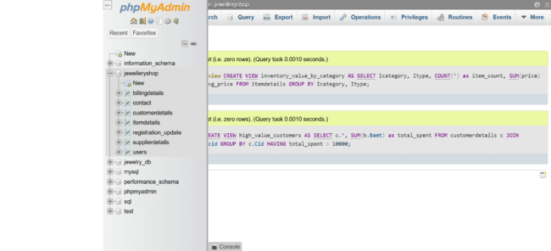

Phase 2

ERD:

Through SQL Self Designed

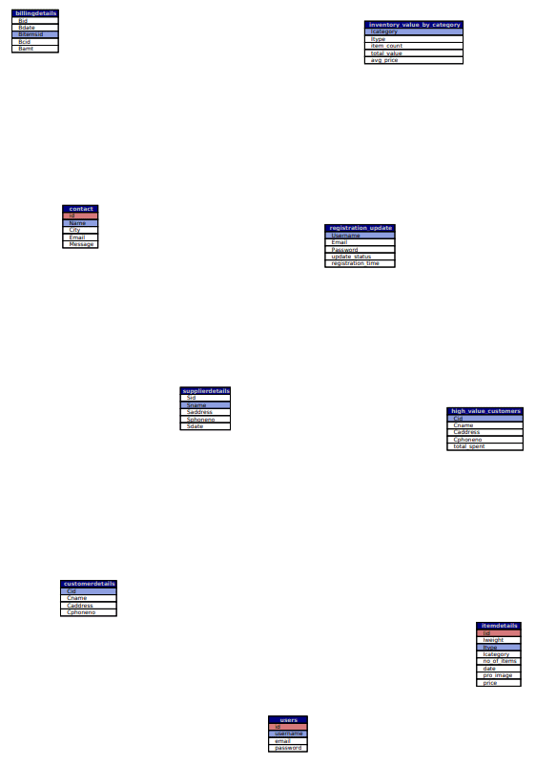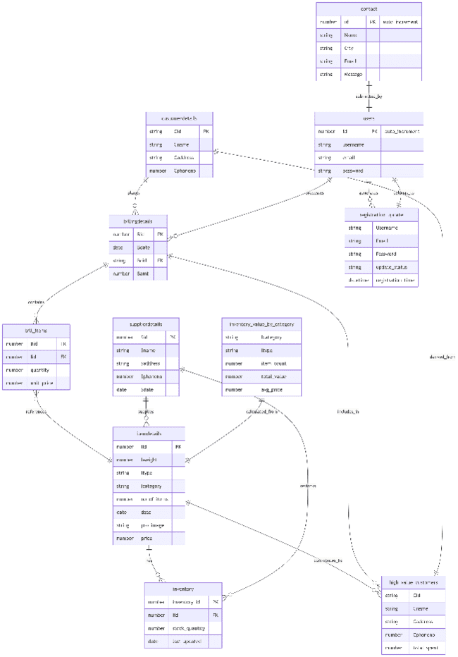

Phase 4

UNF:

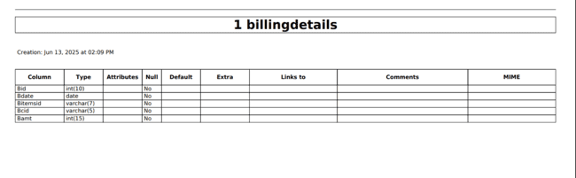

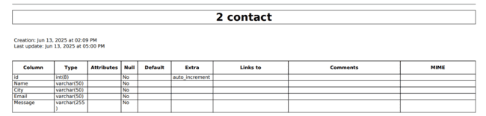

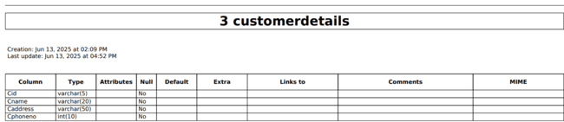

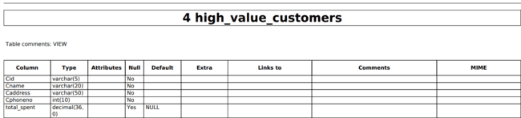

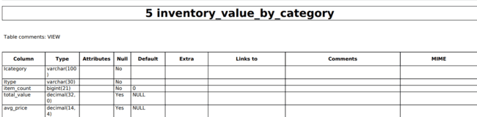

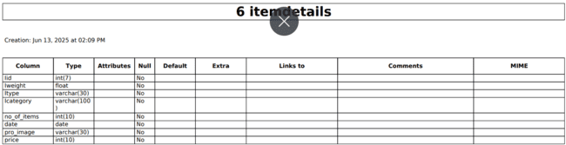

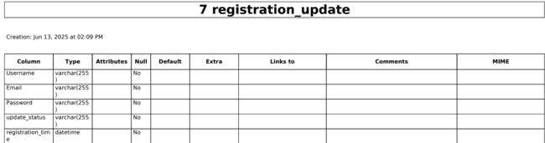

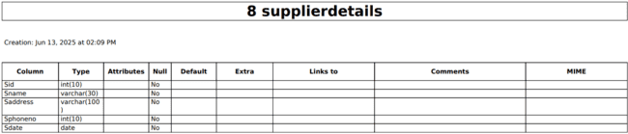

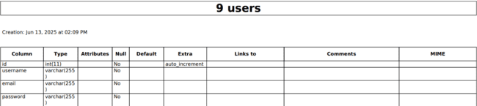

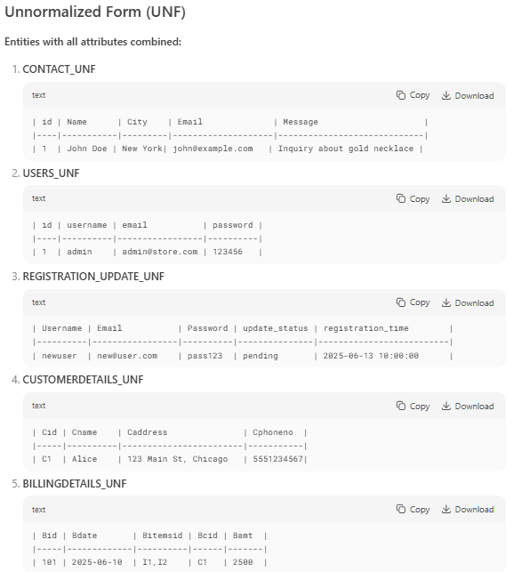

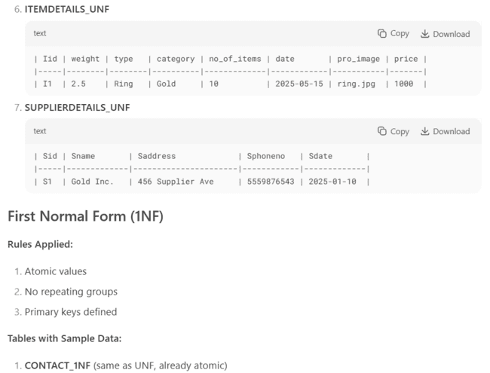

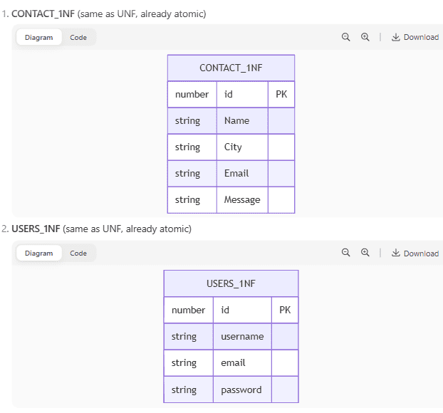

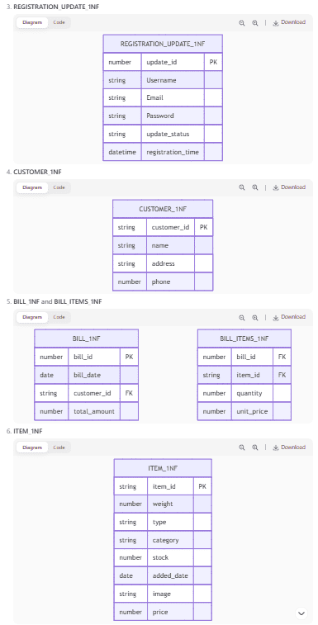

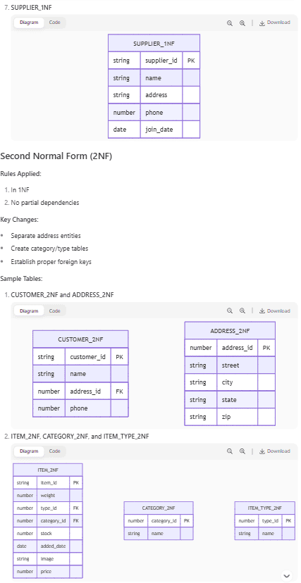

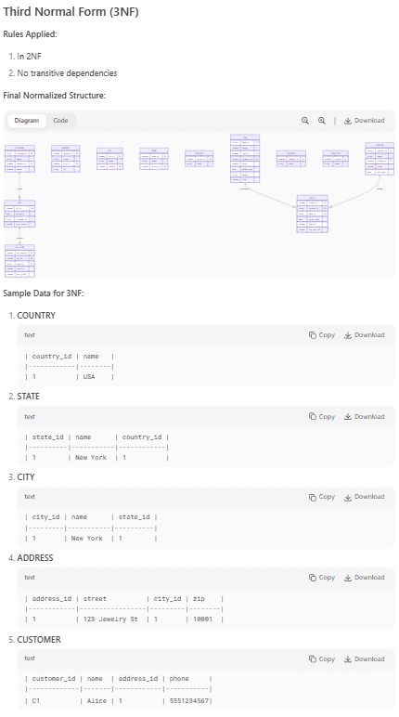

**Phase 3**

**WEB PAGES**

Home Page:

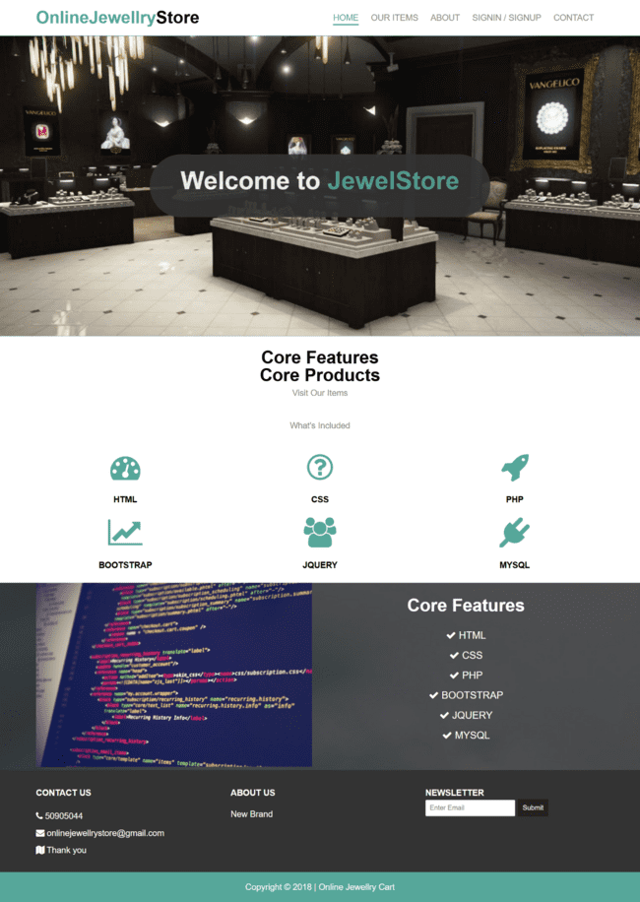

Register Page:

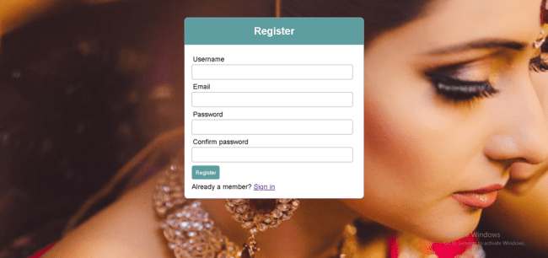

Login In Page:

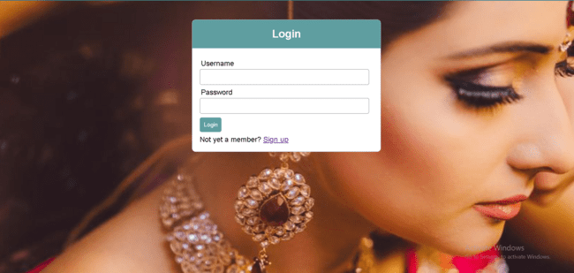

Cart Page:

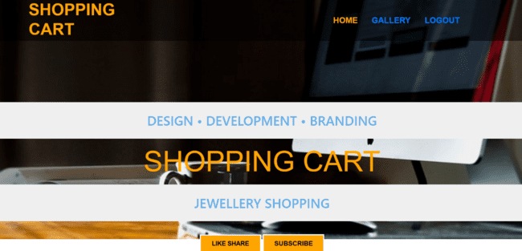

Clear Session Page:

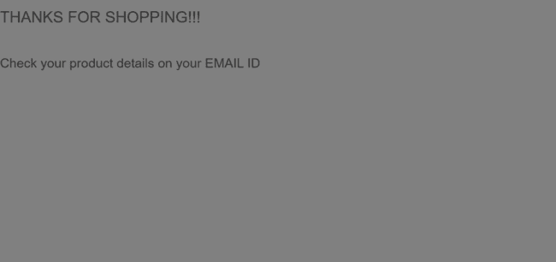

Check Out:

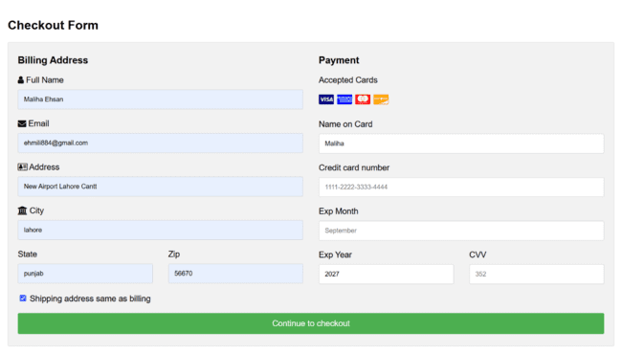

Supplier Information in Admin Panel:

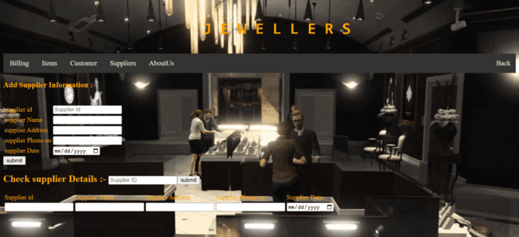

Contact Us Page:

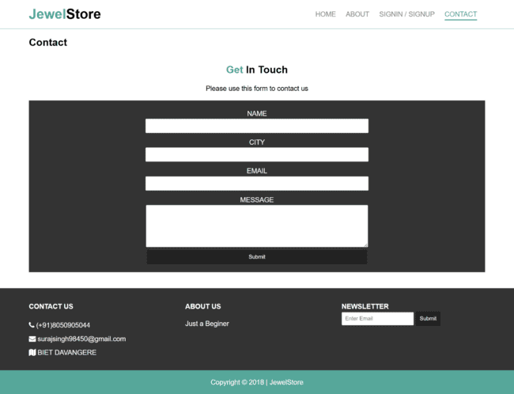

Items Page:

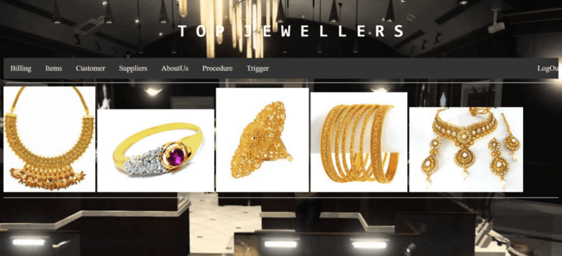

Premium Items Page:

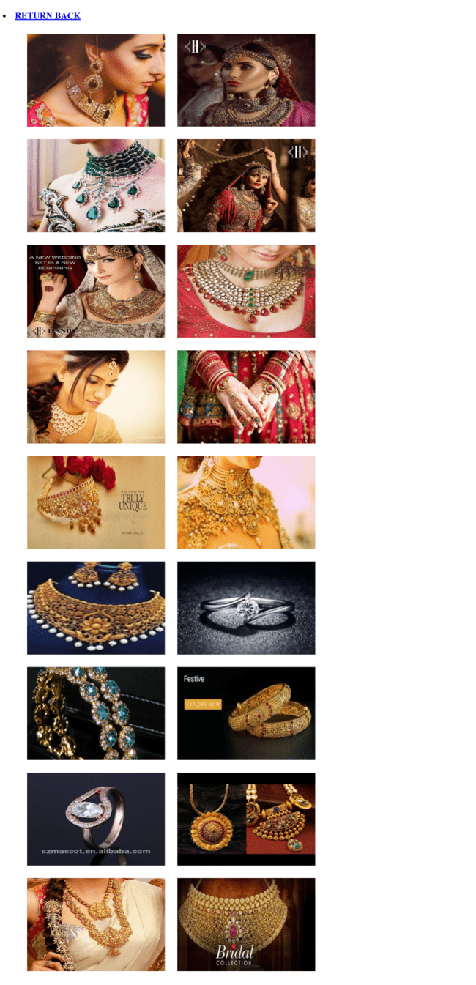

**Phase 6: bonus part**

Database connection

Before adding new customer: 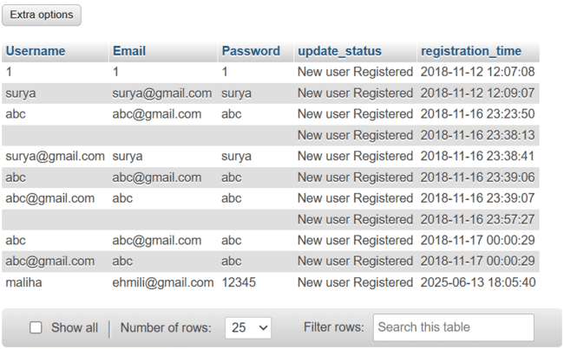

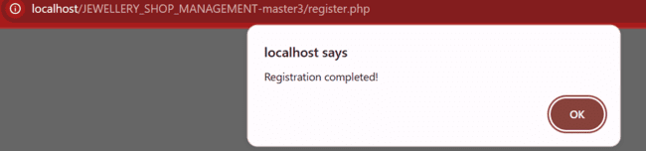

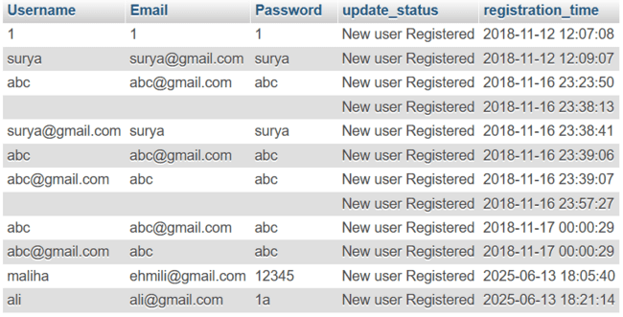

Hence new user is registered successfully and stored in database too.